Candidates for Board of Directors

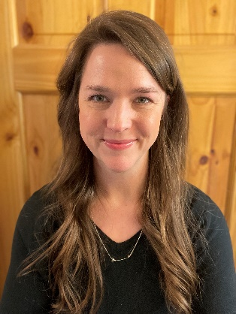
Amy Barnhill – Amy is a Budget Analyst for the Missouri Department of Conservation (MDC), where her position’s primary focus is on the Department’s Internal Expenditure Plan. She has worked for MDC for just over a year, starting on October 1, 2023. Before coming to MDC, Amy worked for the State of Missouri for nearly 10 years, serving most recently as the Lead Compliance Specialist for the Community Development Block Grant program at the Missouri Department of Economic Development (DED). Amy earned her Bachelor of Science in Business Administration, Accounting, Finance, and Management from Columbia College in 2013. Amy lives with her husband, Justin, on his family farm in California, MO with their three daughters: Dillon, Corey, and Jae.


Brian Ham - Protection Branch Major/Programs Supervisor Brian Ham has been a joint member of CECU since 1994. He started working for MDC out of college as a part-time Hourly employee for Wildlife Division in 1993 and then was accepted to and graduated from the 1996 Agent Training Academy. Brian and his family utilize CECU for their financial needs. In his spare time, he enjoys fishing for large catfish, shooting sports and spending time with family and friends.

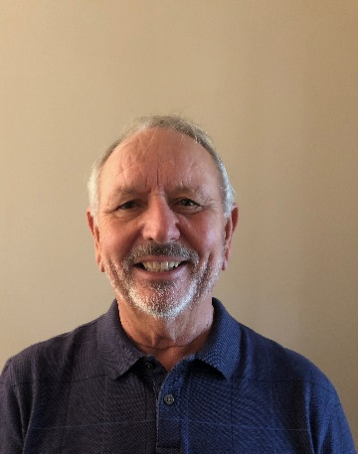
Carl Hauser – Carl is currently a member of the Board of Directors and would be honored to serve another three-year term. He retired from the Conservation Department in 2002 after 30 years with the Division of Forestry in Southwest Missouri and the Central Office. Carl has been a member of the Credit Union since 1976, previously serving terms on both the Credit Committee and Board in the 1990’s. He has done business with several financial institutions and finds the Credit Union to be the best in terms of products and services, with a very friendly and helpful staff. If re-elected to the CECU Board, he would do his best to help make sure the Credit Union continues its excellent service to its members.

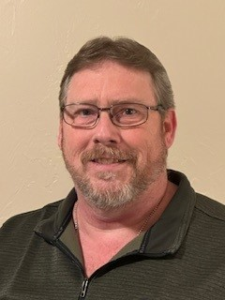
Paul Lepper – Paul is the Information Technology Infrastructure Supervisor with the Missouri Department of Conservation (MDC), where he has been employed for nine years. In his role, he oversees critical IT infrastructure, ensuring reliable and secure technology operations that support the department’s mission.

He has been a proud member of the Conservation Employees Credit Union (CECU) for approximately five years. His experience with CECU has been outstanding, and the professionalism and dedication of the individuals he has encountered—both personally and professionally—have been of the highest standards. Beyond his professional life, he enjoys spending time at Pomme De Terre Lake camping during the summer, indulging in great BBQ, and creating lasting memories with my grandkids.

Serving as a member of the CECU Board would be an honor. He is committed to upholding the high standards that make CECU an exceptional institution and would work diligently to support the interests of both current and future members. It would be a privilege to contribute to the continued success and integrity of CECU.

Candidates for Supervisory Committee

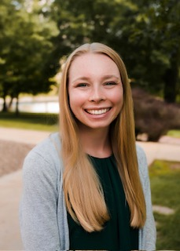
Alicia Engelbrecht – Alicia is a Budget Analyst here at the Missouri Department of Conservation Headquarters in Jefferson City. She has been with MDC for over a year now and has enjoyed connecting with staff and providing quality assistance through her role. As a Budget Analyst, Alicia provides assistance through her role in health insurance administration, as well as serving as the Budget Analyst for the Goal 3 Team here at MDC, to help administer financial resources in a manner which instills public trust and accomplishes the Department’s mission. She has a Bachelor of Science Degree in Business Administration from William Woods University and Master of Business Administration Degree from William Woods University. She is a former collegiate athlete in Cross Country and Track and Field. Alicia has many hobbies which include road running and racing, hiking, swimming, reading, cooking, and spending time with family and friends. Alicia appreciates your consideration and would be honored to serve the members of CECU if elected.

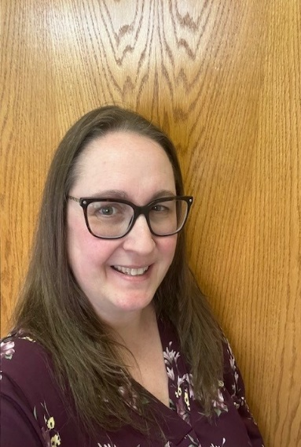
Samantha Mueller – Samantha is the Branch Office Manager for the Science Branch with the Missouri Department of Conservation here in Jefferson City. She has a Bachelor of Science Degree in Business Administration from Columbia College and a Master of Business Administration Degree from William Woods University. Samantha has over 25 years of experience in the customer service industry and has worked for the State of Missouri since 2003 for various departments before joining MDC in June of 2021. She is married with two children. She has many hobbies which include being the Girl Scout Leader for Troop 70178 out of Wardsville Mo, camping, hiking, event planning, swimming and just spending time with her family. Samantha would be honored to serve on the Supervisory Committee.

